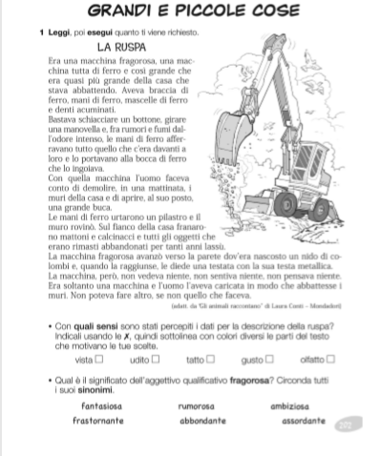

NOMI
https://eliza.zanichelli.it/eliza/Zingarelli/#/allenamento/621/1

CONCORDANZA NOMI ARTICOLI AGGETTIVI
https://eliza.zanichelli.it/eliza/Zingarelli/#/allenamento/754/1

USO DELL’H
https://eliza.zanichelli.it/eliza/Zingarelli/#/allenamento/614/1

